VINCE Q. VILLAR SCREENSHOTS

2-ECE-D HANGAROO GAME

**FUNCTION 1 - isWordGuessed**

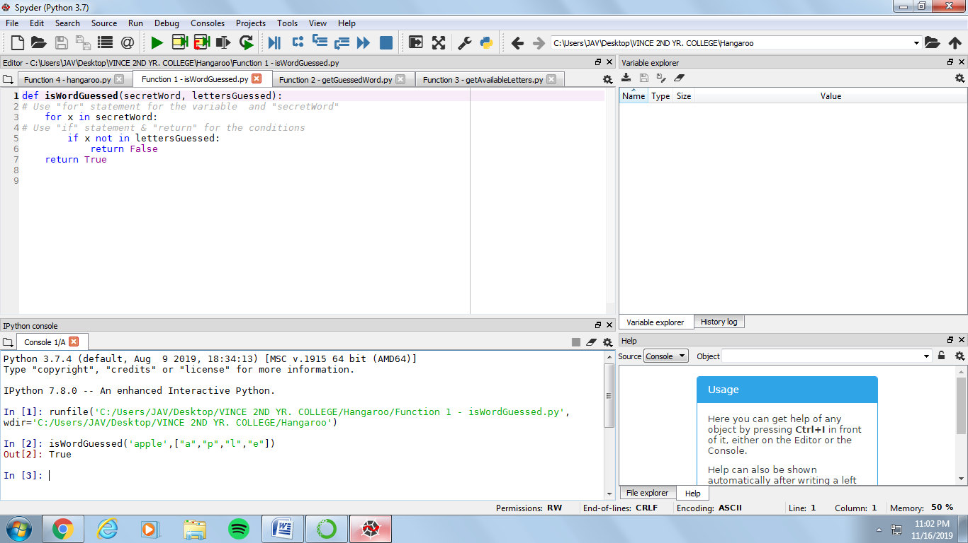

**FUNCTION 2 - getGuessedWord**

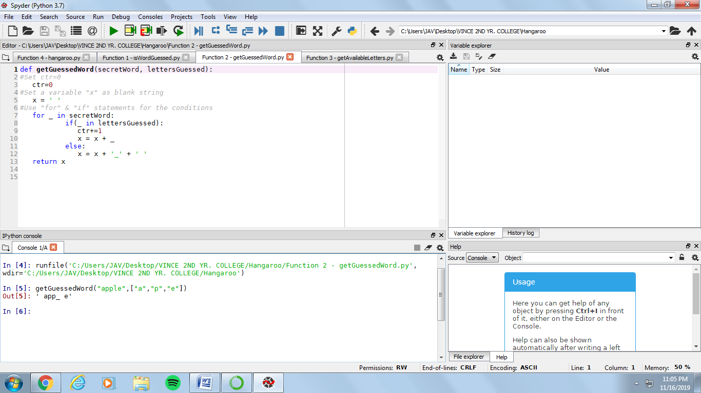

**FUNCTION 3 - getAvailableLetters**

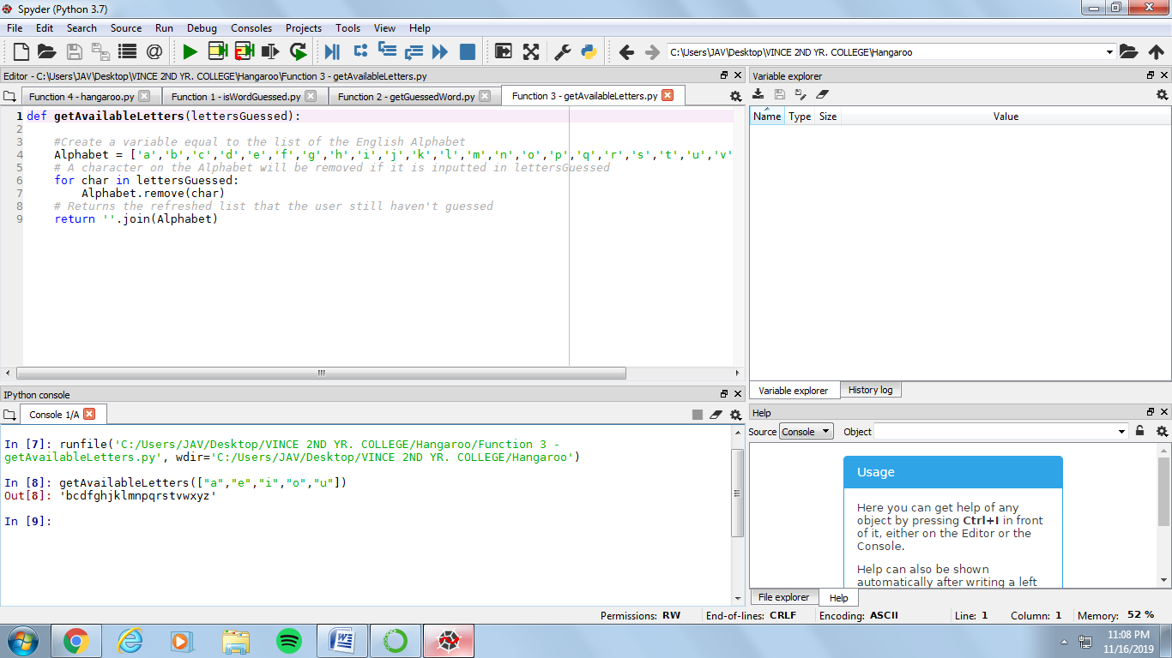

**FUNCTION 4 - hangaroo**

Start of Game

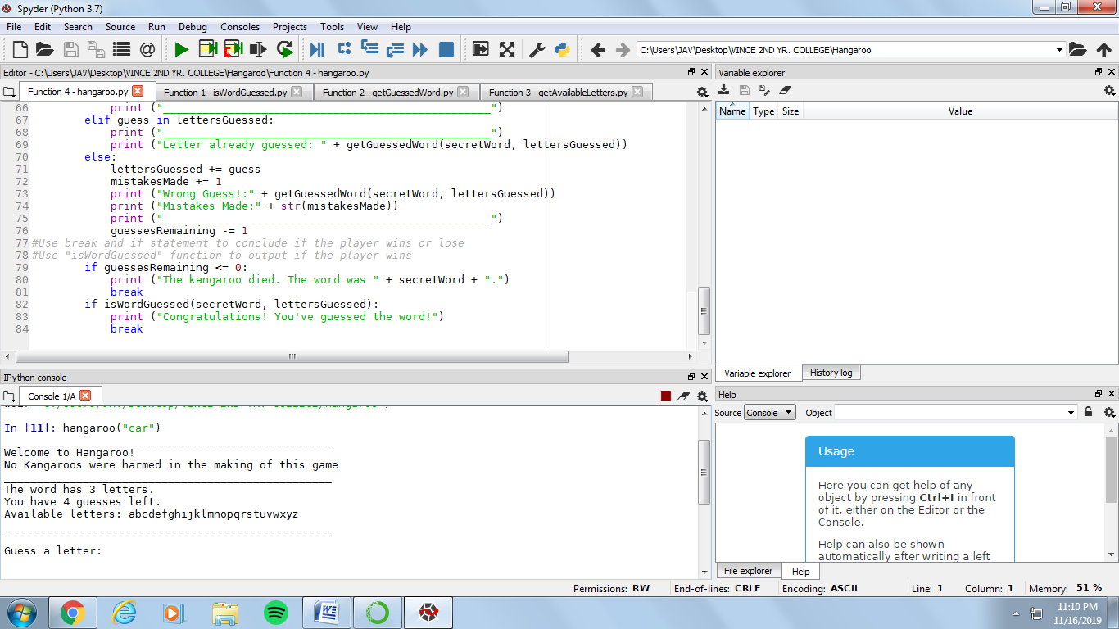

If the word is guessed

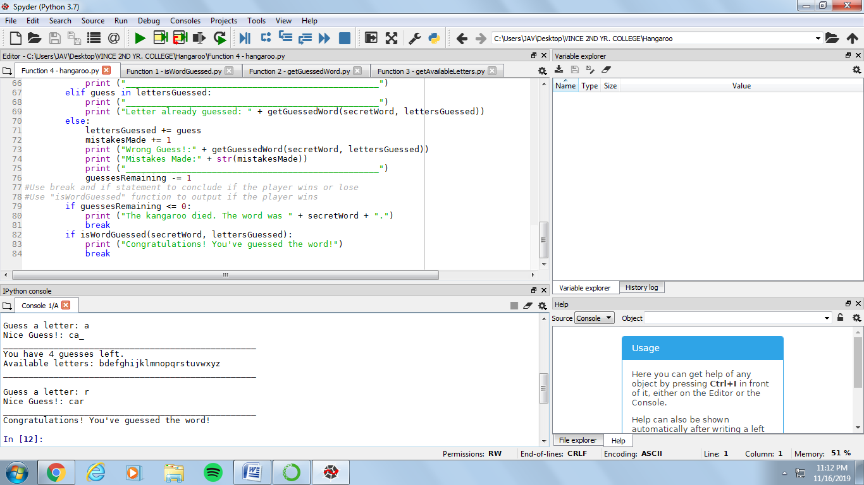

If a letter is repeated

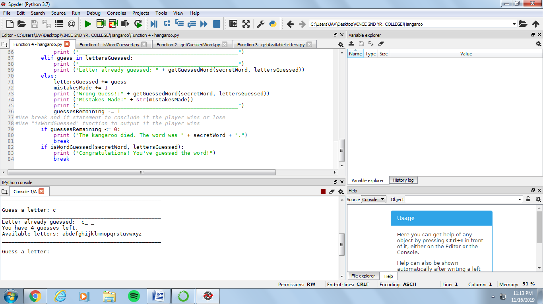

If the player loses

